**Helix – the AI Powered SDLC**

*Intelligent, Integrated*

# Executive Summary

Helix unifies the SDLC (Software Development LifeCycle) into an integrated, AI-powered platform that super charges engineer productivity. It replaces fragmented tools and workflows with a seamless, modern experience. ***Helix will super charge the concept-to-customer velocity*** ***while significantly reducing cost.*** Like the double helix in DNA, Helix forms the intelligent, integrated backbone of the modern SDLC.

This document covers the pain points, user stores, roadmap, stakeholders, AI opportunities, risks, and success metrics.

# Why?

Modern services development is hampered by fragmented tooling, duplicated workflows, and context-switching. Just as world-class products require world-class foundries, exceptional services demand a seamless, intelligent foundry as well. Helix is our bold response: an integrated, AI-powered platform that unifies the developer journey from concept to customer.

# User Stories: Pain Points Across the SDLC

Helix addresses pain points across every stage of the individual, team, and customer workflows.

**Individual** - **Inner Loop** (code, test, debug).

Individual

Team

Customer

**Team - Middle Loop** (reviews, integration).

**Customer** - **Outer Loop** (deploy, feedback).

# 

The following user stories reflect the daily friction developers face due to fragmented tooling and disconnected workflows.

**Individual Workflows - Inner Loop**

1. **“As a new developer**, I spend hours setting up my environment and configuring tools for each repo, leading to lost onboarding time and inconsistent debugging experiences.”
2. **“As a senior engineer**, I find myself duplicating effort across multiple testing frameworks and linters because different teams use different standards.”
3. **“As a developer fixing bugs**, I switch constantly between logs, code, docs, and observability tools — losing focus and momentum.”

**Team Workflows – Middle Loop**

1. **“As a code reviewer**, I often receive pull requests without context or with inconsistent formats, making reviews slow and subjective.”
2. **“As a team lead**, I waste time reconciling CI results across multiple pipelines that aren't standardized across teams.”

**Customer Workflows – Outer Loop**

1. **“As a dev on-call**, I struggle to trace customer-facing issues back to recent code changes due to fragmented observability and monitoring tools.”
2. **“As a developer seeking feedback**, I rarely get actionable insights from real user behavior or post-release issues — feedback loops feel broken or delayed.”

# Schedule & Milestones

**Crawl (0–3 months)**

* Journey mapping - Inventory existing tools, gaps, and duplication
* Launch stakeholder advisory group
* Deliver a draft tool consolidation plan

**Walk (3–9 months)**

* Consolidate core tools - editor plugins, debugging, unit tests
* Integrate AI-based static/dynamic analysis
* Measure early productivity gains

**Run (9–18 months)**

* Launch AI-powered insights engine (developer health, code quality)
* Sunset legacy systems and measure total cost savings
* Celebrate developer success stories and showcase gains

# 

# Stakeholder Engagement & Program Kickoff

1. **Engage key stakeholders**: Leaders, DevEx teams, IT, compliance.
2. **Steering committee**: Engineering, Security, PM, DevOps.
3. **Developer listening sessions**: Gather raw feedback across orgs.
4. **Kickoff summit**: Align Objectives and Key Results.

# Top Risks and Mitigations

|  |  |
| --- | --- |
| Risk | Mitigation |
| Tool resistance from teams | Offer migration support and early wins |
| Lack of leadership buy-in | Use Objectives and Key Results to tie to business outcomes |
| Scope creep | Phased roadmap guardrails and steering committee approvals |
| Legacy dependencies | Phased deprecation, wrappers for transition |
| Security/compliance | Integrate early with security, set policy baselines |

# Getting Endorsement

* **Build the narrative**: “It’s not just a tools cleanup — it’s a developer experience revolution.”
* **Show cost of inaction**: Lost productivity, increased defects, talent attrition.
* **Secure executive champion**: Senior Vice President level sponsor.
* **Use data**: Developer surveys, tool usage metrics, time-to-release delays.
* **Highlight AI opportunity**: “AI to enhance every stage of the SDLC.”

# AI: Where It Adds Superpowers

|  |  |  |
| --- | --- | --- |
| Stage | Problem | AI Opportunity |
| Coding | Boilerplate, slow ramp-up | AI pair programming, code suggestion |
| Debugging | Time spent on root causes | AI log analysis, intelligent breakpoints |
| Static analysis | Rule-based tools, noisy results | AI-prioritized findings |
| Code reviews | Delays, low quality | AI review, comment summarization |
| Testing | Test gaps, flaky tests | AI-generated test cases, anomaly detection |
| Integration | Pipeline failures | Predictive failure detection |
| Deployment | Manual steps, rollback fear | AI-based canary rollout planning |
| Monitoring | Reactive issue discovery | AI-powered observability, user sentiment |

# OKR – Objectives and Key Results (6–9 months)

**Objective**

An intelligent and integrated services engineering platform that amplifies engineer productivity from concept to customer.

**Key Results**

1. Reduce average context-switching time by 30% as measured by internal telemetry.
2. Migrate 60% of teams to consolidated inner loop toolset (editor, debugger, unit testing).
3. Improve engineer satisfaction score by 20% (survey baseline vs. 6-months).

# Measuring Progress: On-Track vs. Off-Track

**On-Track Indicators**

* Monthly adoption growth
* Milestone delivery within 10% schedule variance

**Off-Track Indicators**

* No reduction in tool fragmentation
* AI tools underused or bypassed

# Design Example – AI Agent for ****New Engineer Onboarding****

***User story:*** *“As a new engineer, I spend hours setting up my environment and configuring tools, leading to lost onboarding time and inconsistent debugging experiences.”*

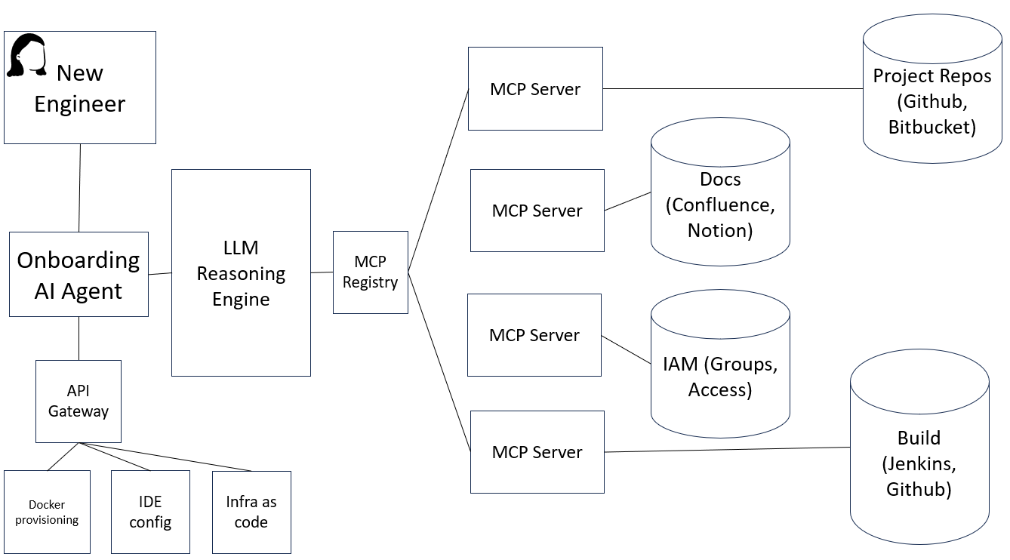

The diagram illustrates the architecture of an **AI-powered onboarding agent** designed to automate environment setup and access provisioning for new developers. The agent uses **Model Context Protocol (MCP) servers since MCP** is fast emerging as a standard for LLM to AI Agent interaction.

### Flow Summary

1. **New Engineer Joins and communicates in natural language with an AI Agent**  
   A new engineer initiates onboarding via an **AI agent** that understands their team, role, and project context.
2. **Onboarding AI Agent communicates with an LLM Reasoning Engine**  
   The onboarding agent is backed by a **Large Language Model (LLM)** **Reasoning Engine**, which consults a **MCP Registry** to interpret project-specific onboarding instructions encoded using the **Model Context Protocol**.
3. **MCP Servers get data and permissible actions in an LLM friendly format**  
   Based on the MCP registry, the agent identifies appropriate **MCP Servers**. The MCP servers are responsible for getting data and actions metadata in an LLM friendly format.
4. **MCP Servers do the following**
   * **Docs**: Connect to relevant documentation (e.g. Confluence)
   * **Identity and Access**: Data and actions for user and group management
   * **Repos**: Information and actions for GitHub or Bitbucket repositories
   * **Build**: Data and actions for Jenkins pipelines
5. **API Gateway identifies the right API to take provisioning actions** e.g.
   * **Docker configuration** (via container templates)
   * **IDE configurations** (e.g., extensions, settings, language servers)
   * **Infrastructure as Code** (e.g., Terraform modules to provision resources)
   * **Secrets Management (**If secure credentials are required (e.g., GitHub tokens

Dependencies

|  |  |  |
| --- | --- | --- |
| Component | Dependencies | Notes |
| New Engineer | Portal or trigger (e.g., Slack, web app, CLI) | Human interaction entry point |
| AI Agent | LLM API, API Gateway, MCP Registry | Core orchestrator |
| LLM | Access to training prompts, MCP schema understanding, Tool plugin API | LLM needs onboarding flows and ability to call APIs |
| MCP Registry | YAML/JSON spec storage (e.g., S3, Git repo, internal DB), Version control | Centralized store for context-driven specifications |
| MCP Servers | IAM (e.g., Okta, Azure AD), Docs (Confluence), CI/CD systems, Version Control (GitHub) | Distributed execution units that fulfill parts of onboarding flows |
| API Gateway | Docker API, IDE Config, Infra-as-Code | Action execution |
| Docker | Docker Registry, Image templates | Spins up dev containers |
| IDE Config | VSCode/JetBrains APIs, Plugin templates | Automates dev environment setup |
| Infra as Code | Terraform, Cloud provider (OCI, AWS, etc.) | Provision cloud resources |
| IAM (Groups) | Identity Provider APIs (Okta, AD, etc.) | Grants access to systems |
| Build Systems | CI/CD platforms (Jenkins), Job templates | Onboards to pipelines and alerts |

World class products are engineered in world class factories. Helix is not just a tooling cleanup — it's a world class, intelligent, integrated foundry for developing world class services.